

A Product of EPICS at Purdue University

in Collaboration with RuTAG at IIT Delhi



# User Manual

Bullock-Driven Tractor

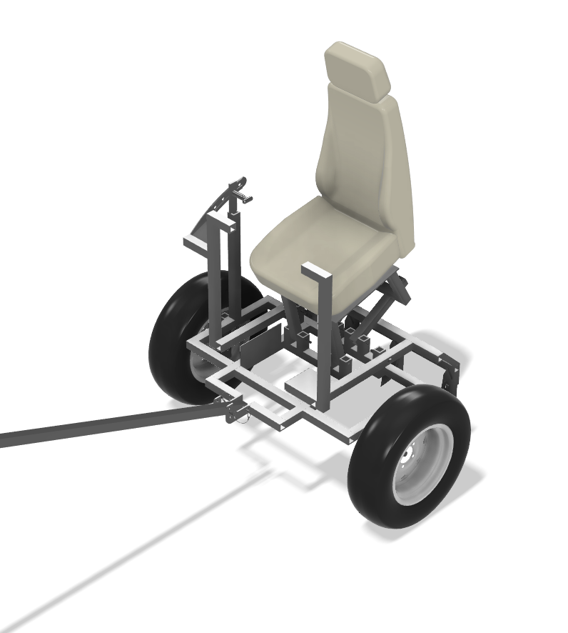

## Contents

1. Introduction ………………………………………………………..................................................... 3
2. Intended Use ……………………………………………………........................................................3
3. Key Features …………………………………………………….........................................................3
4. Parts Needed ........................................................................................................................4
5. Assembly Instructions (video included) ………………………………………........................4
6. Operational Instructions ………………………. ………………………………………....................7
7. Safety Instructions…………………………………………...........................................................8
8. Device Features....................................................................................................................9
9. Harnessing the BDT............................................................................................................9
10. Maintenance and Care………………………………………......................................................10
11. Disposal Requirement …………………………………….………………………..…………………...10
12. Contacts ...............................................................................................................................11

## Introduction

Welcome to the Bullock-Driven Tractor (BDT) manual. This simple, efficient tractor is designed to support rural farmers in India with their agricultural needs, helping them to efficiently plow, till, and carry out various farm operations using bullocks. This manual will guide you through the usage, maintenance, and safety instructions for your tractor. Please read the manual thoroughly before use.



Intended Use

Bullock Driven Tractor is farming equipment intended to be used in tandem with a pair of bullocks only. The draught power of the animal drives the BDT for plowing and cultivating farms with various attachments.



Device Features

* The Bullock Driven Tractor (BDT) is much more efficient than the conventional plow.
* A seat has been installed allowing the farmer to remain seated throughout the entire process.
* With the use of the spring plunger, the farmer would now be able to adjust the height of his seat based on his liking.
* The extended footrest prevents the farmer from resting his feet between the frame and the lifting mechanism, reducing the risk of injury.



Key Features

* Bullock powered mechanism: Guided bullock is used to pull the tractor.
* Frame: supports the entire structure and connects plow, wheels, and the locking mechanism.
* Locking Mechanism: Ensures stability during operation by locking the intended height. Prevents lifting mechanism from changing heights while in motion.
* Lifting Mechanism: Lifts plow spikes in and out of the ground by relying on the user’s leverage
* Plow Attachments: Points of attachment for the plow spike.
* Hitching attachment: This facilitates the connection between the tractor and the bullock
* Wheels: Designed for easy movement of uneven terrain by relying on independently rotating wheels. Independent wheels also allow a smaller turning radius.
* Foot Protector: Prevents the farmer's foot from moving beneath the lifting mechanism, reducing the risk of injury while operating the spike-lifting mechanism.
* Hitching Rig: Used in connecting the hitching bar to the frame.
* Hitching Bar: Serves as a link between the tractor and the bullock.

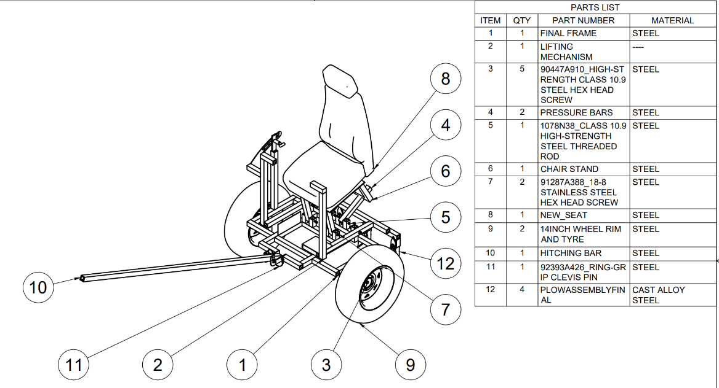



Tools and Parts Needed

Excluding: Frame, lifting mechanism, plow spike attachment, seat/seat attachment, and pressure bars. These parts will be manufactured by RuTAG. The following components can be bought and replaced by farmers when wear and tear is occurring.

* Wheels – 350 mm (x2)
  + Wheel Bolts - 22 mm x 8.8 mm (M16)
  + Wheel Nuts
  + Wheel Washer - 44.45 mm Outer Diameter, 20.62 mm Inner Diameter, 3.02 mm
* Seat Bolts (x2) (M10)
* Locking Mechanism Bolts (x2) (M14)
* Pressure Bar Threaded Rod (x1) (M10)
* Spring Plunger – 80 mm (x1)
* Plow Spikes - 267 mm arc length, 76.2 mm wide, and 7.95 mm thickness (x4)
* Chain – 534 mm (x1)
* Frame
* Lifting Mechanism
* Adjustable wrenches (x2)
* Rubber mallet or hammer, may be useful for fitting bolts

Assembly Instructions

1. Attach the wheels to the sides of the frame with the use of the wheel bolts (M16) using two adjustable wrenches. There are two holes – placement will vary based on the size of the wheel. **This step will require two (2) M14 bolts and two (2) nuts.**
   1. This model has a 350mm diameter wheel and was placed on the bottom most hole.
      1. 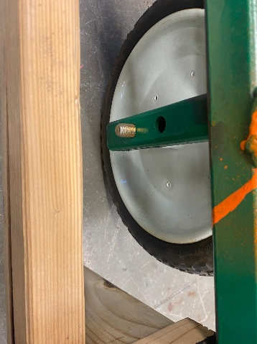
   2. If there is space between the wheel and the frame, add washers to reduce clearances.

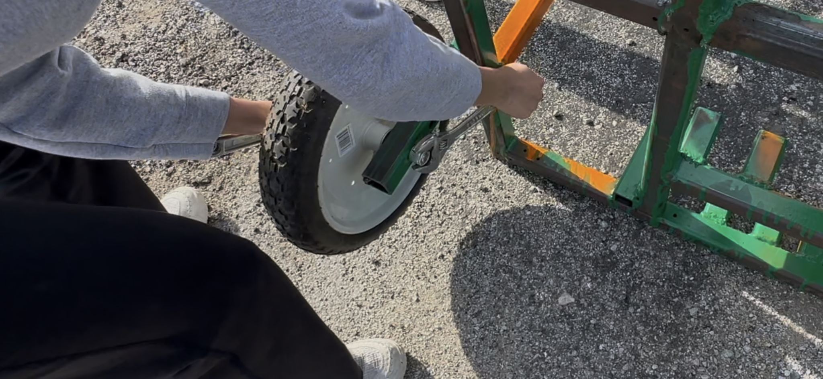 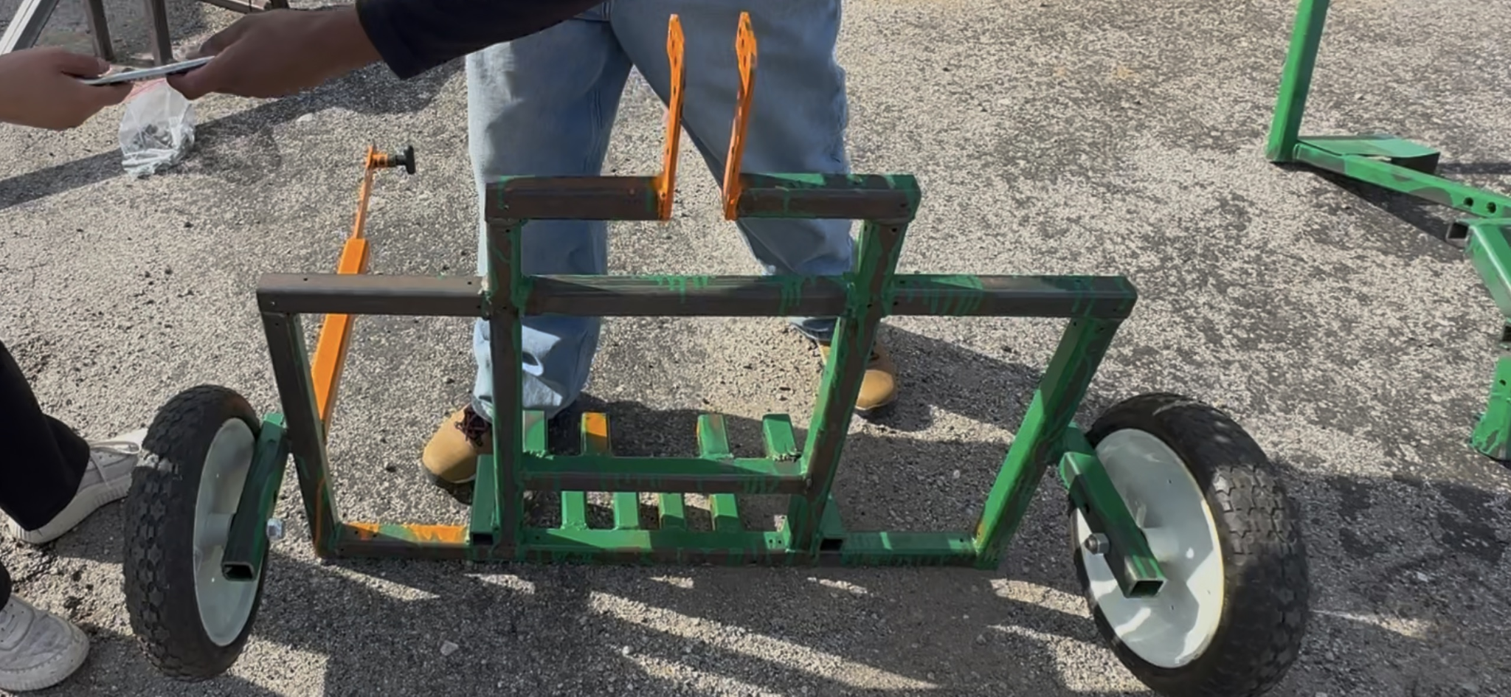

1. Align the lifting mechanism with the designated mounting holes on the frame. Each hole will require an M14 screw and nut. Using two adjustable wrenches, securely tighten the nut to ensure the mechanism is firmly attached and has created a pin joint.
   1. If there are any gaps between the frame and the bolt, use washers to fill in the space and

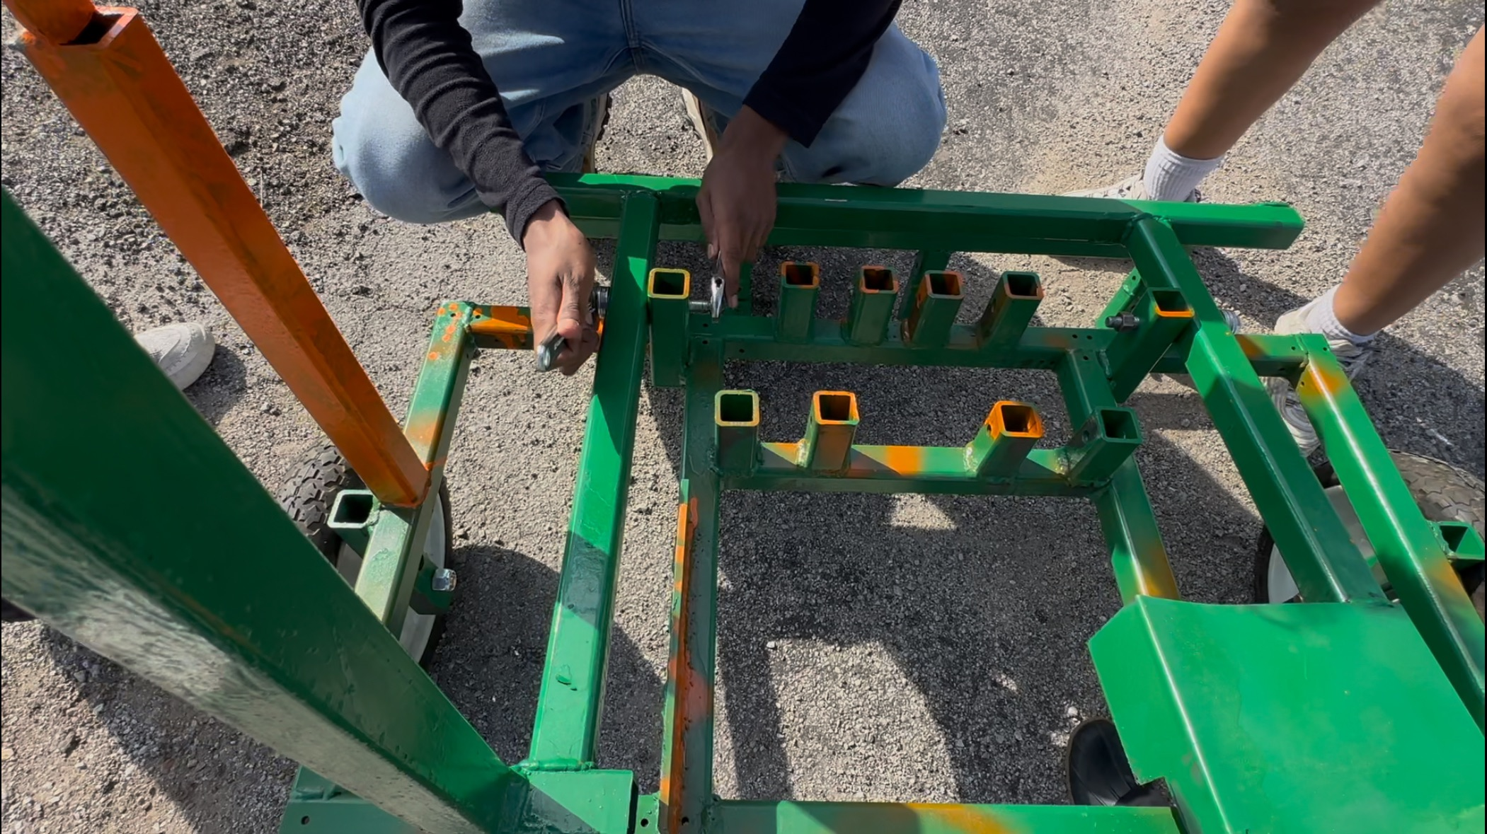

1. Locate the four vertical bars on the frame in the back. Place and align the two pressure bars in between these vertical bars and secure them into place with the 30cm M10 threaded rod. Place nuts on either end of the threaded rod to secure it into place.

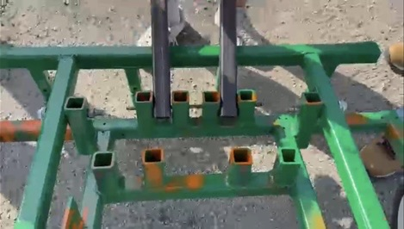

1. Place the seat behind the frame right above the pressure bar. Use a screw (M10) to get through the holes as shown in the picture. Later, use nuts to ensure that the seat is tightened. (explain that seat sits ON the bars) (one person holds seat up and other person does bolts while telling person to adjust) (switch order to put pressure bars second and seat first)

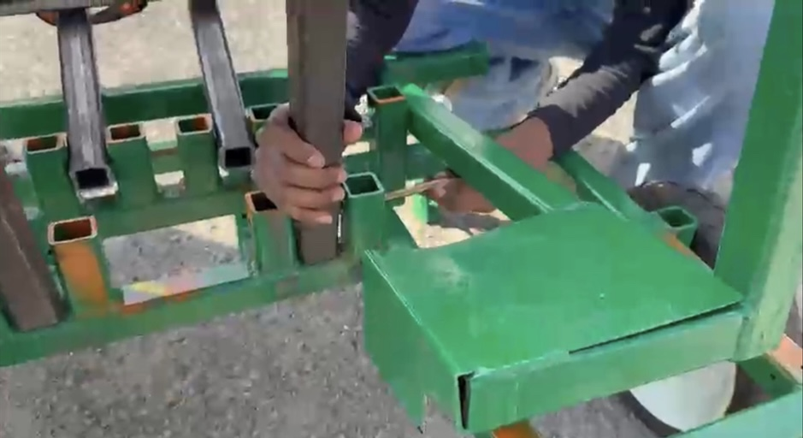

1. Once attached, use the spring plunger and connect it to the locking mechanism. This can be done by turning the spring plunger through the hole and ensuring that the plunger has gone through one of the holes as shown in the picture below.

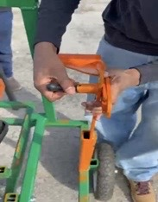 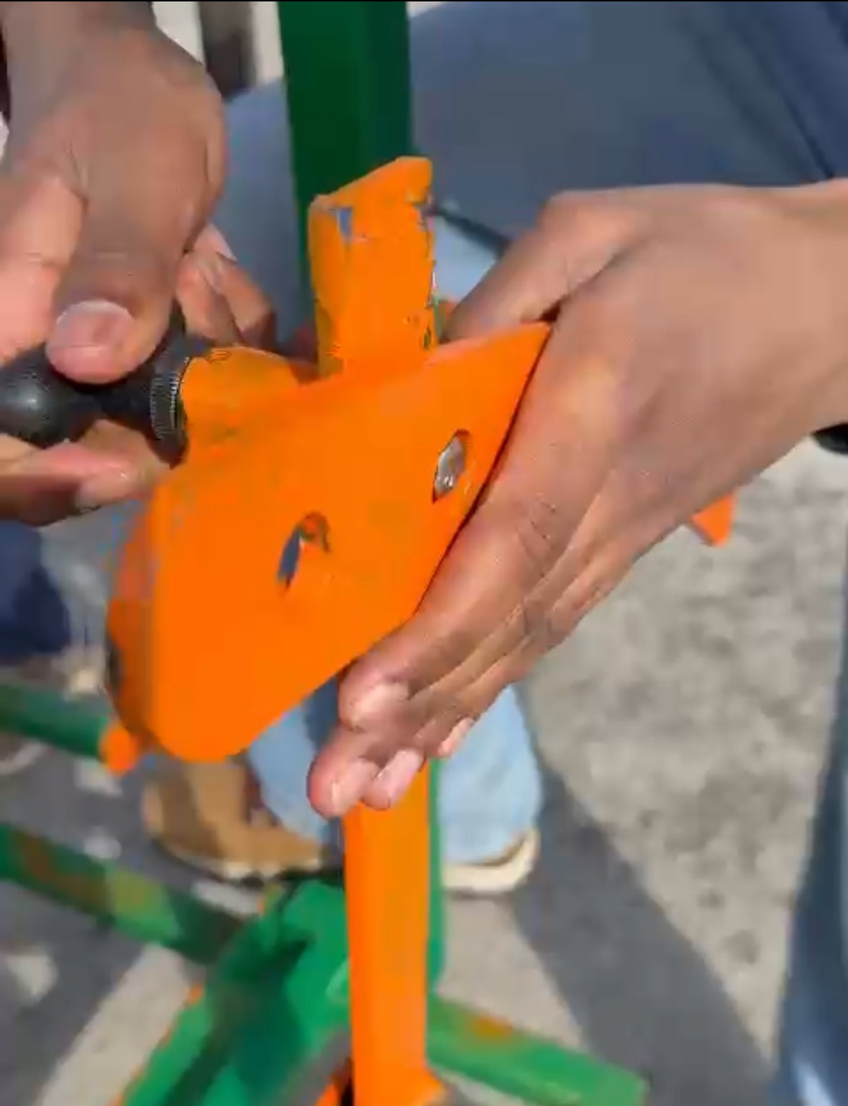

1. Attach the plow spikes to the backside of the frame. This can be done with the use of nuts, wrenches and bolts (M12). (specify bolt comes in from back, nut onto bolt and threaded rod) (one threaded section in each hole)

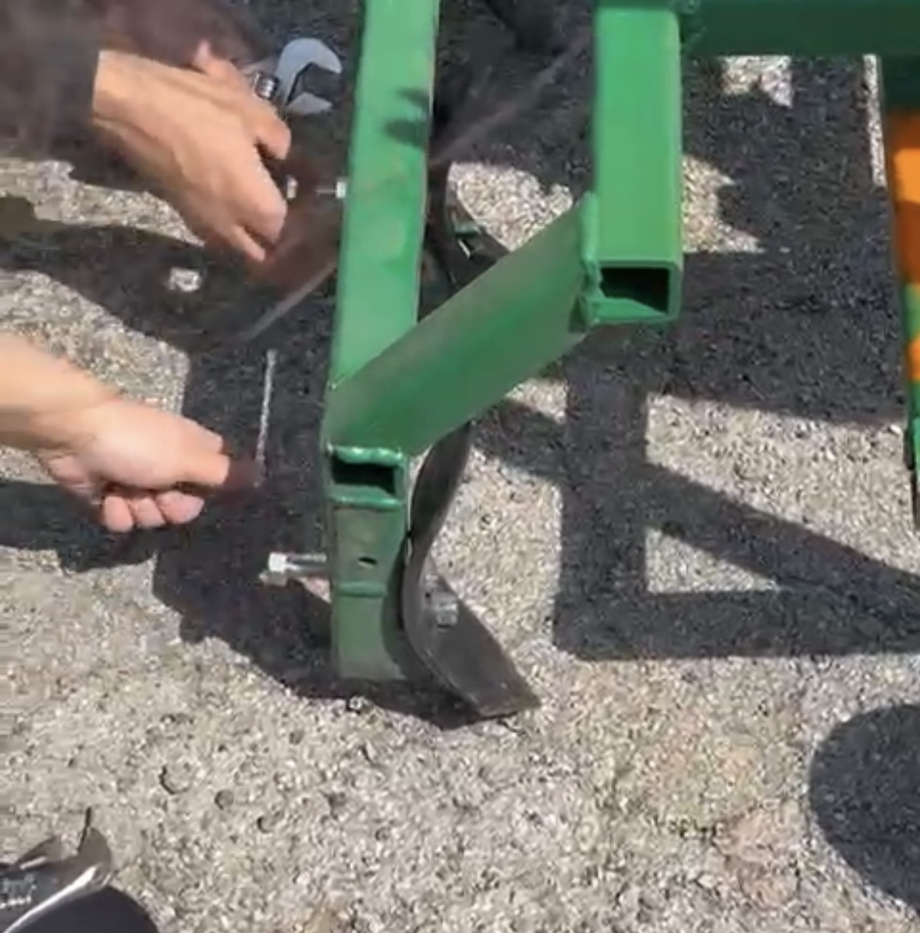 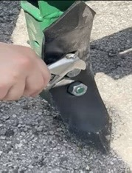

1. At the end, attach the hitching bar to the frame with the use of wrenches and nuts (M14).

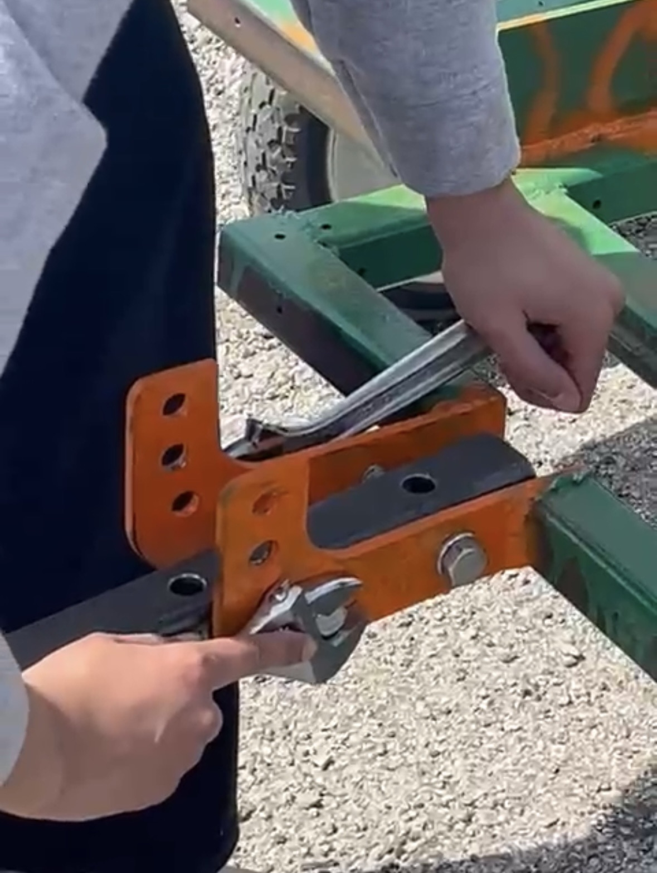

If there is any uncertainty regarding any of the steps, please refer to the video provided for clarification.



Operational Instructions

Before Starting:

* Inspect the tractor for any loose bolts or broken parts.
* Ensure the bullocks are properly hitched and comfortable.

During Use:

* Adjust plow depth by shifting the locking mechanism height as needed with the spring plunger to the user’s right-hand side.
* Use body weight on the foot pedal to adjust the plow depth concurrent with the spring plunger.
* Hold tractor handles firmly to maintain balance and direction and rests body weight

After Use:

* Unhitch the tractor from the bullock.
* Clean the plow spike of any mud and debris.
* Store tractor in a covered area.

Safety Instructions

Since farming conditions can be environmentally brutal, we have optimized the tractor to allow the farmer to operate it without any additional PPE. Although a hard hat could be worn to protect from spontaneous falls if wanted. The tractor includes multiple pinch points we would like to make the farmer aware of before beginning use.

1. Locking Mechanism - As the arc bar moves through its range of motion it creates a pinch point for fingers or clothing. We recommend being wary of this space while operating the lifting/ locking mechanisms.
2. Frame and Lifting Mechanism - As the plow comes in and out of the ground there becomes a pinch point between the footrest and the frame of the tractor. While we recommend resting your foot on this rest thereby mitigating any danger if that is not your desired foot position, we advise caution around this area.
3. Mount and Dismount - Due to the tractor being on two wheels, it is imperative to be cautious when mounting and dismounting as it could be prone to tipping. Always ensure it is stable after hitching and be wary of weight changes as you are stepping onto different parts of the frame.
4. Footrest - In terms of resting your feet, we recommend keeping your feet in the manner shown in picture 1 below. Resting your feet in a manner similar to the one shown in picture 2 can hinder the lifting mechanism and thus could cause problems with the lifting of the plow spikes as needed.

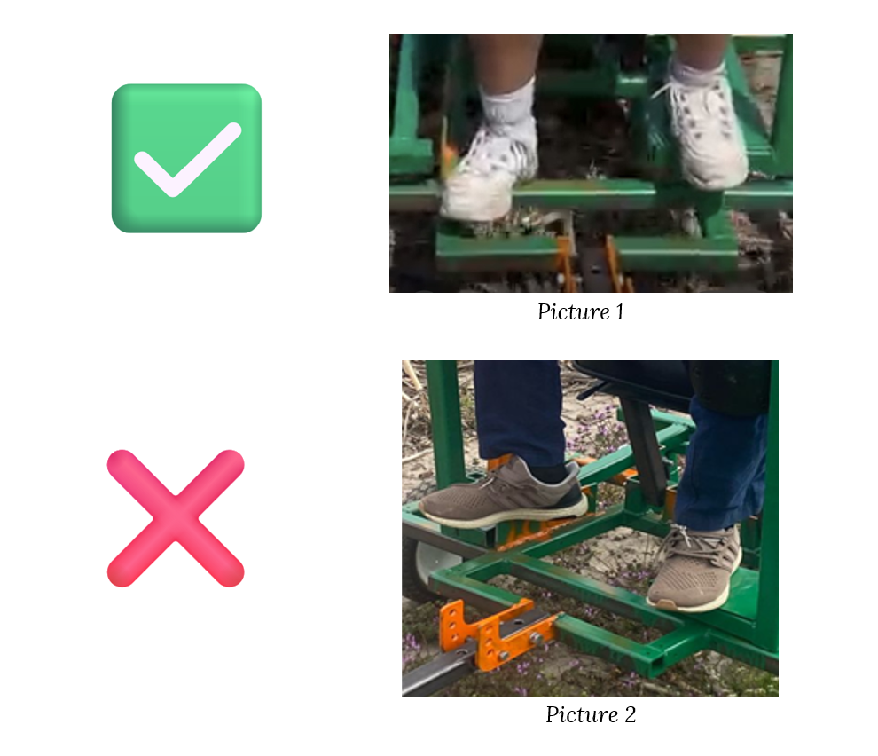

Harnessing the BDT *(Adapted from RuTAG)*

* Place the yoke just in front of the withers or the shoulder blades of both the bullocks.
* Hold the yoke in the said position by straps or ropes on either side of the bullock's withers.
* Fix the tug beam in the middle of the yoke between the two bullocks using a rope.
* Fix the other end of the beam with the BDT using a nut and bolt for hauling with the bullock.
* Adjust the height and angle of the beam by inserting the bolt into the appropriate hole provided on the vertical plates of the hitch for the bullock.



Maintenance and Care

* Check the tightness of nuts and bolts put in.
* Make sure the spring plunger is fully and securely inserted into the designated hole.
* Ensure that the plow spikes are positioned at an appropriate height from the ground to allow smooth and efficient movement of the tractor. After adjusting the height for user comfort, it is recommended that the tip of the plow spike lightly contacts the ground.
* If there is corrosion or visible erosion of the plow spikes, it is recommended to replace them using bolts and nuts of the appropriate size
* Check the tightness of the hitching screw to ensure that the hitching bar is tightly stuck to the frame.
* Clean the BDT after each use to prevent the parts from rusting.
* If slipping is noticed repair or replace the winch.
* Replace the wire if breakages and thinning are observed.
* Maintain appropriate tire pressure.

Disposal Requirement *(Adapted from RuTAG)*

* Dispose metallic parts in accordance with relevant local and national legislation.



**Contacts**

Primary Contact: RuTAG – IIT Delhi, [rutagiitdelhi@gmail.com](mailto:rutagiitdelhi@gmail.com)

Secondary Contact: EPICS – INDIA Purdue University, [epics@purdue.edu](mailto:epics@purdue.edu)